Engineering Geology of Tunnels
Introduction
A tunnel is much more than just a tunnel. It serves ant of myriad functions – highway, railroad, or rapid artery; pedestrian passageway; fresh water conveyance, cooling water supply, waste water collector or transport; hydropower generator; or utility corridor. In cross-section it takes one of the several shapes – circular, mullticurve, horseshoe, cathedral arch, arched, or flat-roofed, and withy clear spans of from a few feet to more than 50 ft and, in cavern form, much wider, its length can vary from less than 100 ft to more than 30 miles. A tunnel can be located in any of variety of places – under mountains, cities, rivers, lakes, sea estuaries, straits, or bays. Finally, a tunnel is constructed in one of innumerable media – soft ground, mixed face, rock uniform, jumbled, layered, dry, wet, stable, flowing, and squeezing.
Influence of Geological Conditions on Design and Construction
There are several particular geological features which are commonly encountered in tunneling operations. These can give rise to difficulties especially in impeding progress and/or increasing the hazardous nature of the operation. Awareness of geological conditions on tunneling operations is a natural extension of a thorough site investigation. Changes in geological conditions which result in decreased competence of the rocks surrounding the excavation often result in increasing tunneling costs in addition to affecting operational and safety aspects. Consequently, in-depth appreciation of the geological conditions plays an important role from design and planning through to construction and eventual commissioning and operation of the tunnel.
The Geological Environment
Tunnels are driven in virtually all the main rock types. Wahistrom gives a detailed account of geological aspects related to tunneling operations and draws attention to the importance of petrology and alteration aspects.
Igneous Rocks
The crystalline nature of igneous rocks signifies high compressive strength with potential difficulties in rock excavation processes, but can also indicate marked competence with the advantages of decreased support needs to achieve an acceptable degree of stability. Igneous rocks can be classified under two broad categories, namely extrusive and intrusive bodies.
The size often crystals of such rocks is generally dependent on the size and geological history of the igneous body. Localized and relatively thin intrusives are usually fine-grained and often possess high strength and significant resistance to weathering by comparison to coarser grained igneous types with similar mineral constituents. Intrusive igneous bodies can range from granitic batholiths exhibiting surface exposure areas in excess of 100 km², to dyke swarms, sills and structurally controlled intrusions of a localized nature. In addition to such intrusive rocks giving excavation problems, they can act as a means of directing water into the path of the tunnel.
Extrusive igneous rocks have emerged in a molten state from the Earth’s interior, and examples include rhyolite and basalt. These rocks have cooled relatively rapidly producing a fine grained structure. Those igneous rocks consisting of volcanic tuff and pumice can be particularly weak and porous and whilst usually exhibiting low strength values with ease of excavation, they can be subject to rapid weathering with accompanying loss of competency. Such rock types can also give rise to significant groundwater problems.
Sedimentary Rocks
The sedimentary rocks are generally regarded as being weaker in strength than the majority of igneous and metamorphic types. Consequently, they do not pose initial limitations to excavation by machine methods, although the effects of stress and advanced weathering, and weakening by action of water can give rise to problems especially where such rock types contain appreciable clay minerals. Wide ranging values in permeability occur in such rocks with some clay beds being impervious to water, whilst other sedimentary rocks act as significant aquifers. There are widely differing degrees of competency and sensitivity to stress resulting in failure and deformation at low stress levels with several sedimentary rock types.
Metamorphic Rocks
These rocks commonly exhibit features namely foliation and schistosity. Rock types such as quartzite, marble, dolomitic marble and hornfels generally exhibit random distribution of mineral components, with minor, if any foliation and consequently display competent properties. Some metamorphic rocks contain an abundance of micaceous minerals which result in well-defined planes of weakness allowing easy splitting, such as slate, phyllite, schists. Micaceous layers can be of significance in influencing the vulnerability of certain metamorphic rocks to weathering processes.
Rock Alteration
The natural processes of weathering produce rock alteration which can be of major to tunneling. Weathering reduces the strength of the rocks and can extend to considerable depths by the action of groundwater movement. Climatic and topographical features in addition to rock types and structure influence the depth of weathering.
Erosion often removes weathered material, but deep channels and narrow valleys frequently remain with weathered material being well concealed from surface observation. Buried zones of weathered rocks may exist under glacial drift materials. Pockets of highly weathered rocks usually contain water and can be under appreciable hydrostatic pressure head. Consequently they can possess the ability to rapidly flow into an excavation if disturbed by underlying or adjacent tunneling activities. Weathered pockets occur in igneous, metamorphic and sedimentary rock types.
Rock Mass Deformation by Folding Action
The intensity of folding reflects the degree of localized distortion and relative slipping/shearing within different parts of the affected rock mass. Folded strata allow natural traps to form which attract accumulation in significant quantities of natural gas, petroleum and water. Flexturally folded rocks essentially represent zones of decreased competence in tunnels. This is by virtue of the likelihood of more intense fracturing and stress relief encouraging increased risk of dislodgement of rocks immediately surrounding freshly exposed tunnel excavations.
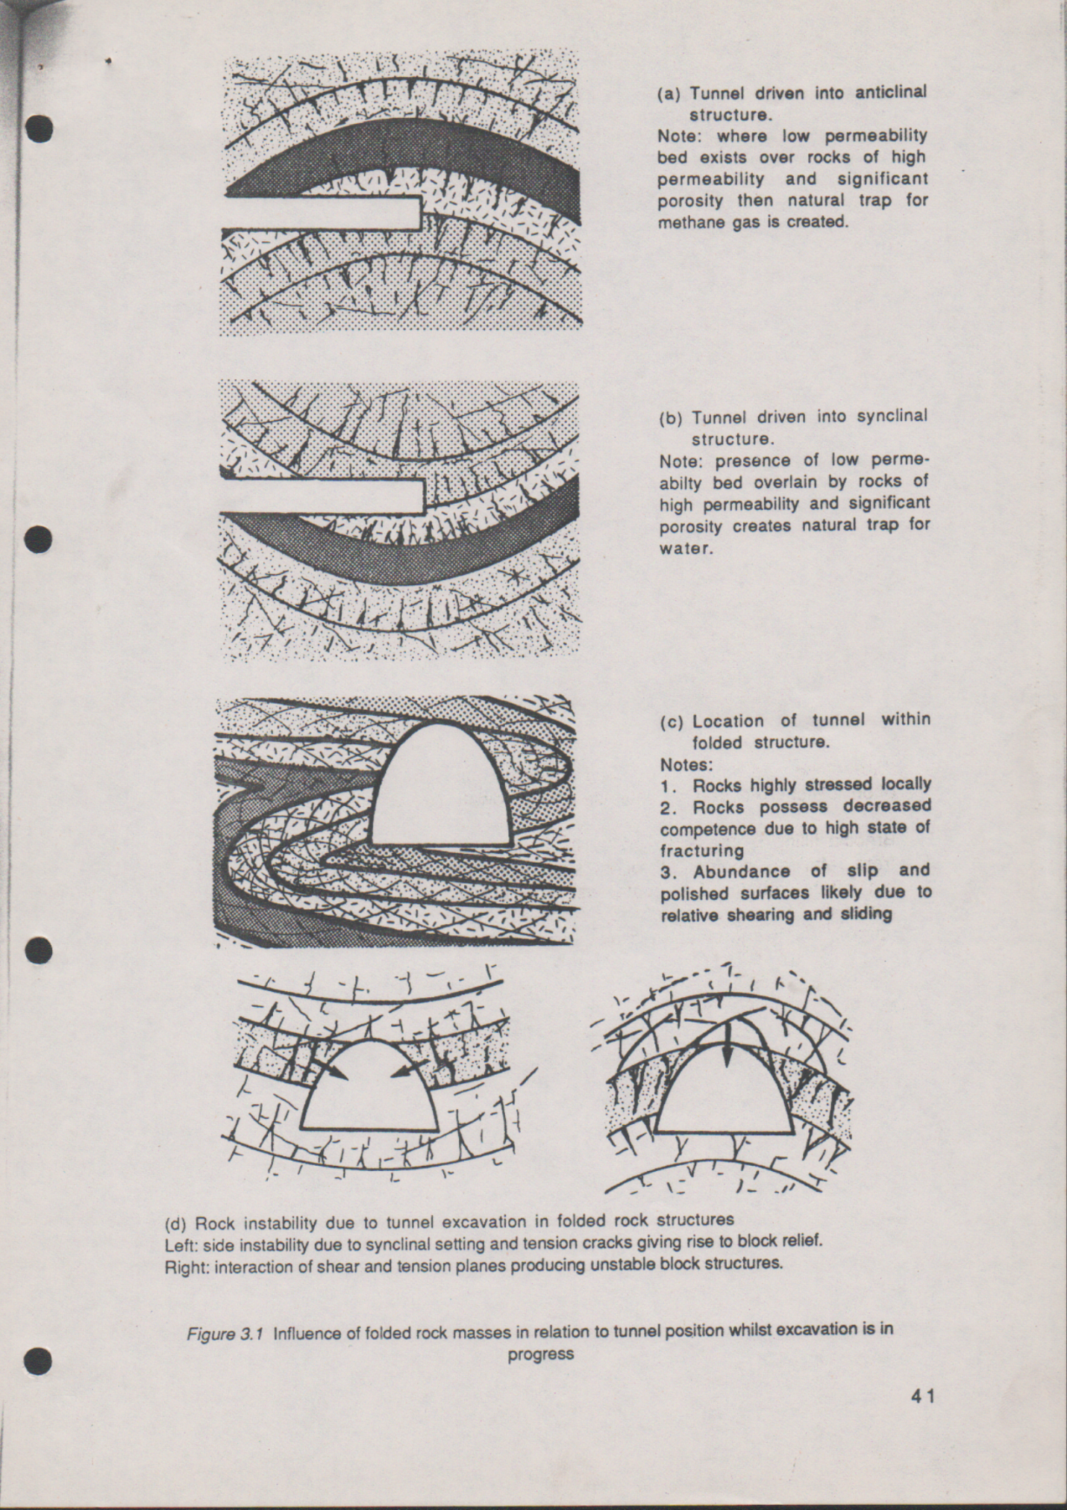
- Tunnel driven into anticlinal structure.
Note: where low permeability bed exists over rocks of high permeability and significant porosity then natural trap for methane gas is created.
(c) Location of tunnel within folded structure
Notes:
- Rocks highly stressed locally
- Rocks possess decreased competence due to high state of fracturing
- Abundance of slip and polished surfaces likely due to relative shearing and sliding
- Tunnel driven into synclinal structure.
Note: presence of low permeability bed overlain by rocks of high permeability and significant porosity creates natural trap for water

(d) Rock instability due to tunnel excavation in folded rock structures.
Left: instability due to synclinal setting and tension cracks giving rise to block relief.
Right: interaction of shear and tension planes producing unstable block structures.

Influence of Faults on Tunneling
Different effects of faults in relation to tunneling are discussed:
- Repeated intermittent movements occur at several sites, particularly where tectonic and igneous activity is still present.
- Faults are frequently preferred paths for groundwater movement but may also act as hydrological barriers.
- Frictional effects of movement along the fault plane can induce wall-rock alteration is likely with other rock types, e.g. igneous, feldspathic, sandstones, etc.
- The width of the fault zone is related to geological and tectonic history and rock types. Fault zones can be tens of meters in width even where relatively minor displacement has occurred between strata and is possibly indicative of several reversals in movement over long periods of time.
- Fault filling and gouge characteristics differ quite markedly and often reflect the degree of influence of groundwater movement. Rock in a crushed and comminuted state caused by grinding action of relative movement along fault plane is commonly referred to as gouge. Water assists in the breakdown of some rocks and the fault gouge often contain clay minerals which can give rise to plastic deformation into underground excavations by virtue of time-dependent behavior properties and swelling pressure effects. Consequently humid conditions and groundwater contact with fault gouge can initiate progressive collapse into tunnel excavations. Fault gouge has minor or insignificant strength and exhibits poor stand-up time. A tunnel intercepting a wide zone of fault gouge beneath and hydraulic contact with water table can experience inrush conditions.
- Relative movement of rock masses produces scratches, grooves and polished interfaces. These can indicate movement direction, but they are of special significance to tunneling in representing planes of very low friction with the ability to readily encourage detachment and sliding of rock into tunnel excavations.
- Faults and interconnecting structures allow circulation of groundwater to penetrate deep below the surface and laterally into side walls. This can produce wall-rock alteration and result in deep seated weathering with consequent loss of competency of rocks appreciably below the surface.
- The orientation of faults in relation to the tunnel line is vitally important since this governs the length of tunnel affected by the fault and its accompanying fault zone.
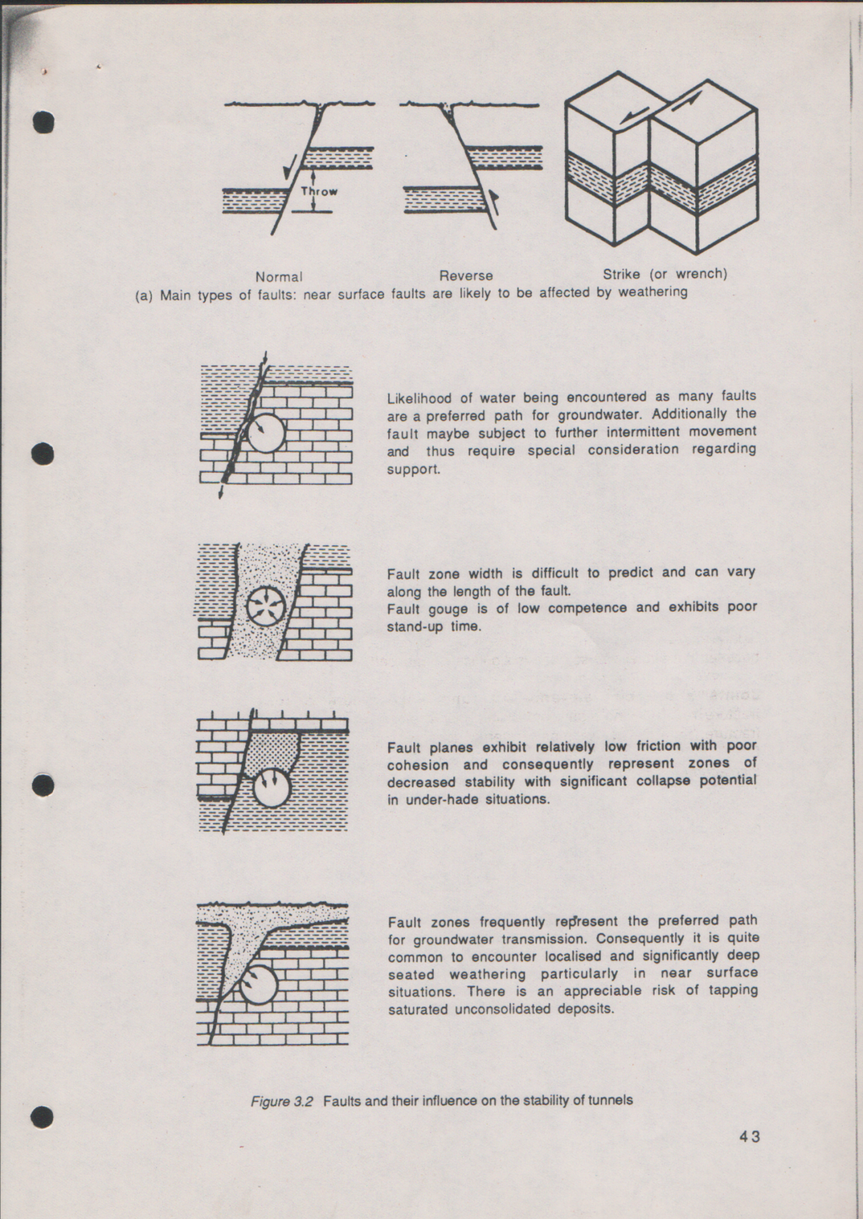
Likelihood of water being encountered as many faults are a preferred path for groundwater. Additionally the fault may be subject to further intermittent movement and thus require special consideration regarding support.
Fault zone width is difficult to predict and can vary along the length of the fault.
Fault gouge is of low competence and exhibits poor stand-up time.
Fault zones frequently represent the preferred path for groundwater transmission. Consequently it is quite common to encounter localized and significantly deep seated weathering particularly in near surface situations. There is an appreciable risk of tapping saturated unconsolidated deposits.
Fault planes exhibit relatively low friction with poor cohesion and consequently represent zones of decreased stability with significant collapse potential in under-hade situations.

Joints and Their Relevance to Tunneling
Joints usually occur in sets. Multiple joint sets run essentially parallel to each other; two further sets of joints commonly exist and are often at consistent angles to each other. Terzaghi remarks that excessive overbreak is attributable mainly to the joint systems in addition to being associated with water problems and he concludes that they always deserve special consideration. Joint spacing increases with depth below surface whilst the width of the joints corresponding decreases with depth.
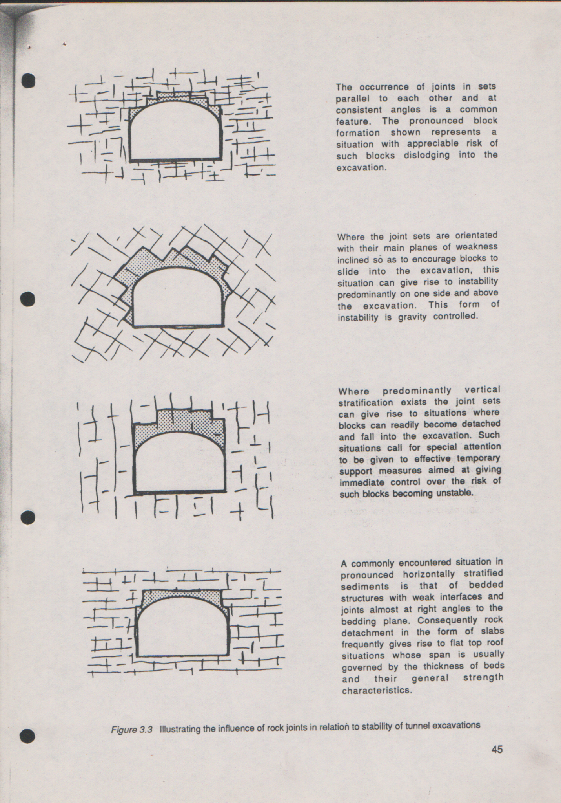
The occurrence of joints in sets parallel to each other and at consistent angles is a common feature. The pronounced block formation shown represents a situation with appreciable risk of such blocks dislodging into the excavation.
Where the joint sets are oriented with their main planes of weakness inclined so as to encourage blocks to slide into the excavation, this situation can give rise to instability predominantly on one side and above the excavation. This form of instability is gravity controlled.
Where predominantly vertical stratification exists the joint sets can give rise to situations where blocks can readily became detached and fall into the excavation. Such situations call for special attention to be given to effective temporary support measures aimed at giving immediate control over the risk of such blocks becoming unstable.
A commonly encountered situation in pronounced horizontally stratified sediments is that of bedded structures with weak interfaces and joints almost at right angles to the bedding planes. Consequently rock detachment in the form of slabs frequently gives rise to flat top roof situations whose span is usually governed by the thickness of beds and their general strength characteristics.

Groundwater Aspects
The presence of groundwater in very large quantities is recognized as a major hazard in addition to causing operational difficulties in respect of tunnel construction works. Potential problems from groundwater inflow during tunneling can be predicted to a large extent in many situations by a comprehensive site investigation employing deep boreholes. The rock types representing significant known, or potential, aquifers within the rock sequence through which the tunnel is to be driven can be generally identified and appropriate provisions made to either control or deal with the water inflow problem. Predicting with accuracy the likely water inflow quantities is, however, difficult, and detailed monitoring and regular review of conditions together with the adoption of special measures such as dewatering or injection programs need consideration.
Floor heave is a commonly encountered phenomenon in tunnels especially in weak sedimentary strata. The following points frequently arise in floor heave situations:
- Weak plastic floor beds are sensitive to stress change in addition to susceptibility to damage by support penetration and weakening by the action of water.
- Extrusion into the tunnel excavation by a weak floor in the form of heaving is essentially representative of the line of least resistance.
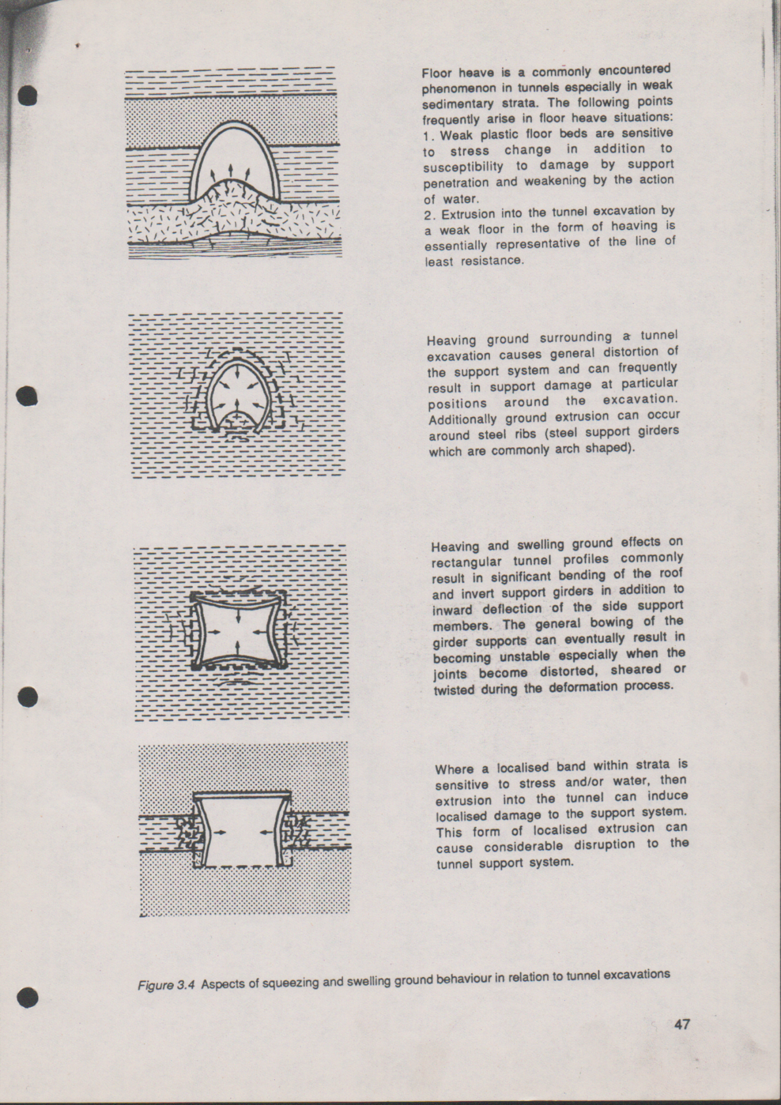

Heaving ground surrounding a tunnel excavation causes general distortion of the support system and can frequently result in support damage at particular positions around the excavation. Additionally ground extrusion can occur around steel ribs (steel support girders which are commonly arched shaped).
Heaving and swelling ground effects on rectangular tunnel profiles commonly result in significant bending of the roof and invert support girders in addition to inward defection of the side support members. The general bowing of the girder supports can eventually result in becoming unstable especially when the joints become distorted, sheared or twisted during the deformation process.
Where a localized band within strata is sensitive to stress and/or water, then extrusion into the tunnel can induce localized damge to the support system. This form of localized extrusion can cause considerable disruption to the tunnel support system.

Squeezing and Swelling Ground Conditions
Squeezing ground commonly refers to weak, plastic rock material which displace into the tunnel excavation under the action of gravity and from the effect of stress gradients around the tunnel opening. Swelling ground displaces into the tunnel opening as result of volume change due to water.

Selection of Shape
The shape of a tunnel cross-section is also called profile. Various profiles are conceivable e.g. rectangular ones. The most widespread ones, however, are circular and (mostly oblate) mouth profiles.
The cross-sectional shape of a tunnel is contingent upon the physical and mechanical properties of the wall rocks, the pressure exerted by the ground on the tunnel, the direction of the pressure, the service life of the tunnel, and the material of the support, which, in turn, depends upon the first four factors.
The properties of solid rocks upon which the choice of the cross-sectional shape of the tunnel depends include hardness, toughness, strength, stability, and jointing. The cross-sectional shapes of tunnels in loose or running ground are determined by the special properties of this ground. Loose ground is characterized by its ability to retain its original shape owing to the weight of its particles and internal friction, with the flat side surface lying at such an angle to the horizon which does not exceed the angle of its natural repose. Running ground is set in motion under the effect of hydrostatic head when tunnels are excavated in it.
Rock pressure upon tunnels depends on the material of the support, the distance from the breast of the active face, the coefficient of internal friction of the rock, and the weight of the ground in the dome space over the tunnel. Rock pressure mat act from the back,, walls and/or floor, it may be considerable or insignificant, vertical or horizontal, balanced or unbalanced.
The service of life of a tunnel influences the choice of the material for tunnel support and thus determining the cross-sectional shape of the tunnel.
The basic cross-sectional shapes of tunnels which depend upon their service life, the material of the support, and the properties of the surrounding ground, are rectangular, polygonal, domelike, crescent (or horseshoe) arched and circular, cylindrical or closed. An oval or ellipsoidal shape of a tunnel is also encountered.
.
Selection of Size
Clearances for Highway Tunnels
Standards for lane and shoulder width and vertical clearances for highways have been established by the Federal Highway Administration (FHWA) and by the American Association of State Highway and Transportation Officials (AASHTO) according of classification. Fig 2.1 shows AASHTO tunnel clearances for a two lane primary highway. For an additional lane, the width should be increased by at least 10 ft, preferably 12 ft. for state trunk highway and interstate systems, the vertical clearance should be at least 16 ft over the entire width of roadway, plus an allowance for resurfacing. For curved alignments with super elevations, clearances may be increased to provide for overhang.
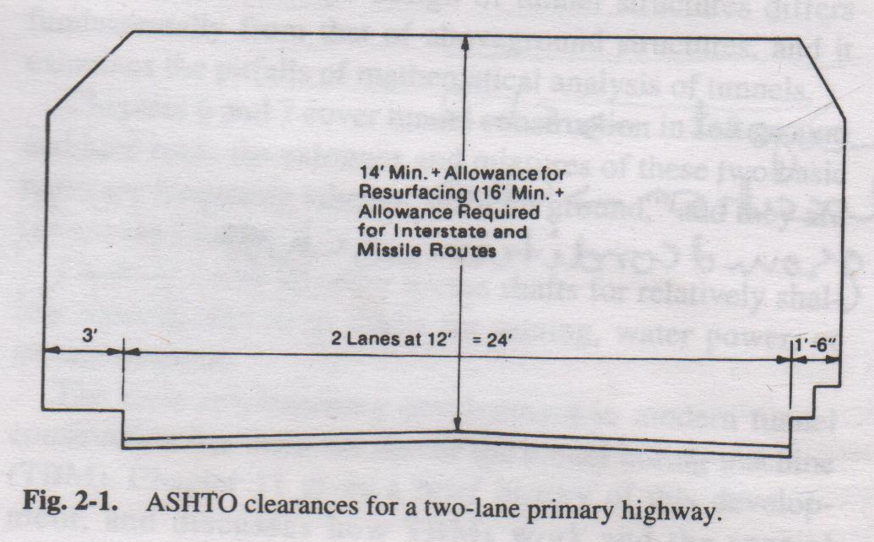
In addition to the width of traveled lanes, it is customary to provide left and right shoulders, flush with the pavement surface. The left shoulder primarily provides a “shy distance” to prevent motorists from moving away from the runnel side wall/ the right shoulder may also provide a refuge area for disabled vehicles. Shoulder widths in tunnels are generally narrower than on open highways, both to conserve costs and in recognition that emergency towing service is generally available on heavily used tunnels. Horizontal clearances on curved tunnels may need to be increased to provide sight distance past the tunnel wall.
In addition to the prescribed vertical clearance for vehicle operation, vertical space must frequently be provided for tunnel lightening, traffic lights, signs, and sometimes ventilation fans. In horizontally curved tunnels, provisions must be made to accommodate super elevation transitions at the end of alignment.
Clearance for Railroad Tunnels
Although clearances may vary for individual railroads to suit the dimension of their equipment, the minimum clearances for tunnels are identical to those recommended by the American Railway Engineering Association (AREA) for bridges on tangent tracks (fig 2.2).
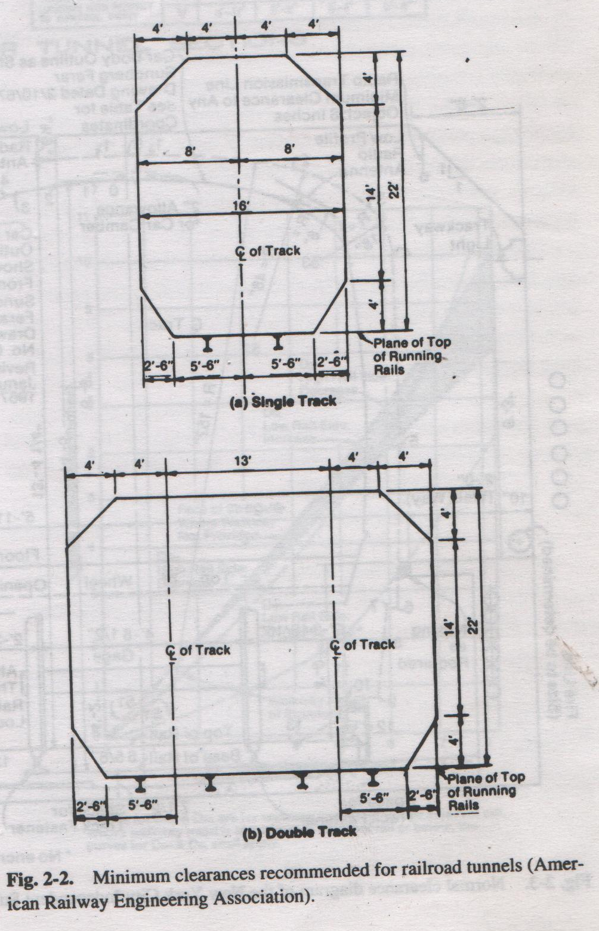
On curved track, the lateral clearances should be increased for the midordinate and overhang of a car of 88 ft long and 62 ft between the centers of trucks, equivalent to 1 in. per degree of curvature. Clearances for super elevation are governed by AREA recommendations.

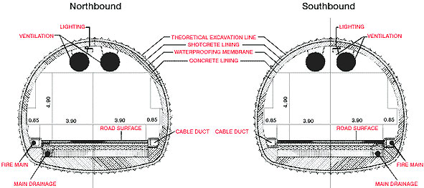
An example of design of tunnel size representing different factors involved in it

Design and Supports of Tunnels
(Operational Criteria and Principal Support Types)

Introduction
When a tunnel is excavated in all but the most competent of ground conditions it is an inevitable consequence that some form of support will be required if the tunnel is to retain adequate stability and/or maintain sufficient dimensions to facilitate its use in the intended manner. The for m and function of the support will vary according to a wide range of factors apart from just geotechnical considerations and it would seem that for every different tunnel there is a different lining solution.
Tunnel Lining: Main Types
Tunnel linings are grouped into three main forms some or all of which mat be used in the construction of a tunnel:
- Temporary ground support
- Primary lining
- Secondary lining
Temporary Ground Support
In rock tunnels where the ground has insufficient stand-up time to allow the construction of the primary lining some distance behind the face, then some form to temporary ground support applied at the tunnel face is required e.g. rock bolts, shotcrete and steel sets. Such support is not required in soft ground in conjunction with a shield driven tunnel as temporary ground support is provided by the body of the shield itself.
Primary Lining
A primary lining is the main structural component of the tunnel support systems which is required to sustain the loads and deformations that the ground may induce during the tunnel’s intended working life. Additional loads may be imposed onto the lining during handling and erection as well as those induced as a result of the shoving forward of the shielded tunneling machine off the last support ring. Such loads may well exceed those imparted as a result of ground loading in certain situation. A further function performed by the primary lining is the control of water egress and ingress.
Secondary Lining
A secondary lining performs certain duties to supplement those of the primary lining which do not involve ground loading. Various tunnels require smooth bore profiles for their intended use, e.g. sewer and water tunnel or aesthetic finishes for public usage, e.g. highway and pedestrian tunnels. Erosion and corrosion protection for the primary lining and further waterproofing may also be required, all of which are provided by secondary linings.
Design Considerations of Lining
Civil engineering tunnels are constructed in the full spectrum of possible ground conditions ranging from soft ground to massive unjointed rock, coupled with various states of in situ stress and hydrology. However, the dimensions and details of a tunnel lining for civil engineering purposes are rarely governed only by geotechnical considerations and the loads and deformations that will be imposed on the lining.
Water
Given that the requirements of the user are established, the first consideration in designing a tunnel lining is that of water. If the lining has to resist hydrostatic pressures either externally or internally then this will in general govern the lining design and control the success of the tunneling operation. A tunnel specification will often state that it should be completely dry for its intended operation; such a condition may not be economically feasible. Therefore, consideration should be given to the tunnel’s intended use and its sensitivity to water leakage either in or out of the tunnel.
There are various methods available to facilitate the waterproofing of a tunnel varying from simple caulking or sealing of the longitudinal and radial joints of the lining to the installation of a full waterproof membrane between either the temporary or primary or primary and secondary linings. Any water trapped behind the lining as a result of such measures is then channeled away. The most common method is that of joint sealing which will inevitably not achieve a completely dry tunnel but may reduce the water inflows to acceptable levels.
Constructability
The next consideration in the design of a tunnel lining is constructability or its inter-relationship with the tunneling method to be employed to drive the tunnel. In soft ground conditions where a shield driven tunnel is required, some form of segmental lining will be required, either bolted or unbolted. Conversely, if the tunnel has an appreciable stand-up time allowing dispensing of the tunneling shield, then the use of a temporary support such as shotcrete followed by either a poured or precast concrete primary lining may be appropriate. In ground with good stand-up times, ribs and lagging or rockbolting can be used as the temporary support followed by a cast in situ primary concrete lining. Thus the choice of lining type may well be made prior to any considerations concerning the likely ground conditions.
Constructability of the lining may also determine the dimensions and type of lining selected. Factors such as handling and erection, jacking loads from the tunnel shield and joint details will all impose certain conditions on the dimensions of the tunnel lining for pre-cast concrete segments which as previously stated mat well exceed the applied loading due to the ground conditions. Similar restrictions also apply to the application of shotcrete with respect to the maximum layer thickness that can be applied without inducing sagging from overhead surfaces and rockbolts with regard to their diameter such that they do not buckle when forced into the hole. One exception to this rule is the use of steel sets which in general are not affected by constructability considerations.
Tunnel Usage
The final consideration applied to lining selection prior to geotechnical design is that of the tunnel usage, or operational criteria. For example, a water transport tunnel requires a lining with good hydraulic efficiency characteristics, thus leading to choice of a smooth bore lining. Similarly, pedestrian and highway tunnels require aesthetic, durable finishes which may facilitate the need for a secondary lining.
Geotechnical Design Considerations
It is evident that the type and dimensions of a tunnel lining in the majority of civil engineering tunnels will be decided upon by the aforementioned factors prior to any consideration being given to the geotechnical environment. That is not to say that lining design in relation to the anticipated ground behavior and the resultant loads and deformations of the support, is not a requirement as indeed it is. This is the especially the case in the present-day environment of client-contractor partnerships and the implicit legal and liability aspects.
The first point to be established is that the design of a tunnel lining cannot be considered as a structure being subjected to well-defined values of loading as there is no absolute certainty of the actual ground behavior following excavation. Thus, the problem should be considered as one related to ground and structural behavior rather than simply one governed entirely by structural features.
The two lining properties which affect the generation of passive earth pressures are axial stiffness and flexural stiffness. Kuesel states that axial stiffness is much more important to a lining than a flexural stiffness as increasing axial stiffness improve the efficiency of the compressive bulging action. Flexural stiffness, however, must also be of relevance as it is only by the deformation of the lining that earth pressures are generated, and a lining with an infinite flexural stiffness, i.e. rigid, would not deform at all.
A third factor which until recently was not a general consideration in lining design is the amount of stress relief and redistribution and consequent ground movement that occurs prior to support placement, and is known as the ‘head-end effect’. The major implication of the head-end effect is that a support installed at a distance behind the face will not be subjected to the full loading and deformations as a result of the full overburden pressure. In fact, even if the support is installed at the face, a degree of stress relief and movement will have already taken place in the immediate ground in front of the face. It is desirable to take account of the head-end effect in lining design, for economic reasons, as it will result in a support which is more correctly matched to the expected ground behavior rather than one which is over-designed if the full overburden pressure is considered.

Common Support Types Used in Civil Engineering Tunnels
As a result of the requirements of civil engineering tunnels and the ground conditions in which they are generally constructed, there are a number of standard types of supports suited to such tunneling applications. The following table summarizes the use of supports in civil engineering tunnels in various ground conditions and includes comments on their various operational features.
Lining Type | Field of application | Operational conditions
- Natural support in rock | - Good quality rock in low stress conditions in relation to rock strength | - Surface sealants may be required to prevent drying and slabbing of rock surfaces
- Rock reinforcement | - Untensioned bolts suitable for good quality rock conditions.  - Tensioned bolts improve effectiveness.  - Mechanical anchors require competent ground for suitable anchorage.  - Cement and resin anchors are suitable to weak ground.  - This support type often used in conjunction with mesh in friable rock and shotcrete as a temporary support.  - Various bolt mediums are available including wood dowels, wire cables and steel. | - Mechanical anchored bolts liable to be rendered completely ineffective by bolt failure.  - Column bonded bolts such as resin anchors can sustain bolt failure but still remain effective.  - No visual indication of failure is given as is common with other support types.  - In certain situations it can also be difficult to incorporate bolting operations within the tunnel drivage cycle without causing drivage delays.
- Shotcrete | - Commonly used in conjunction with rock bolts and mesh as a temporary support system in rock tunnels where a concrete lining cast in situ is used as the primary support.  - Used to seal off rock surfaces and prevent spalling and slabbing of weakened and loose rock. | - Application of shotcrete is dependent upon skill of the nozzle operator.  - Steel fiber additives have been developed to improve tensile and shear strengths of shotcrete.  - Shotcrete rebound can be a problem in certain conditions and under particular forms of application with some types of shotcrete.  - Lends itself to tunneling by drill and blast or roadheader forms of tunnel excavation but not with full face TBMs.
- Standing support; steel types | - Adaptable to a wide range of rock and soil conditions and tunnel profiles.  - Used as temporary support this can be encased with concrete poured in istu to form a primary lining.  - Equally strong in tension and compression. | - Relatively lightweight by comparison to concrete segments.  - Failure is mainly due to plastic hinge formation and out-of-plane movement in the axial direction.  - Performance of support is affected by rib type connecting plates, axial support legs no soft floors.  - Rigid and yielding types are available.
- Segmental supports (flexible) | - Constructed of cast iron, steel or concrete (reinforced) for a wide variety of soil conditions.  - Limited to circular profiles (and similar shapes) as they are often used behind tunneling machines.  - Steel linings are relatively rare in UK due to the cost of steel and corrosion problems, although such supports are quite common in the US. | - Bolted linings erected in the tail of the shield and subsequently grouted.  - Expanded, unbolted linings find use in self supporting clays and do not require a shield tail.  - Unbolted segmental rings with grouting are suitable for some rock tunnels.  - Cast iron has good water sealing properties compared with concrete.  - Concrete is relatively weak in tension compared to compression.  - Concrete possess cost advantages over cast iron.
- Monolithic concrete supports (rigid) | - Generally used as primary lining in rock tunnels or as secondary linings in soft ground.  - Normally erected after significant stress relaxation as under loading, bending moments in the structure will be significant due to its rigidity.  - Generally applied over some temporary or primary support systems.  - Possess good hydraulic and leakage control characteristics. | - Thickness of lining generally governed by the clearance between the existing support systems and the interior form required in the placing of concrete.  - Sufficient space needs to be provided to permit the concrete to flow from he slick line in the crown to all location between the form and tunnel profile.  - Bending moments are the over-riding consideration in the design of a rigid lining.  - Tendency is for rigid concrete linings to fail in shear rather than pure bending.  - Applicable to large and irregular shaped excavations.

