Dams and Dam Sites
Dam
A dam is a barrier built across flowing water in order to hold it back, often creating a water reservoir or lake behind the dam. Dams may be built to provide water for irrigation or town water supply, control the amount of water in rivers or to provide hydroelectric power. Dams may also be built to control effluent from industrial work sites such as mines or factories.
Factors Affecting Dam Design
The type and size of dam constructed depends on the need for and the amount of water available, the topography and geology of the site, and the construction materials that are readily obtainable. Dams can be divided into two major categories according to the type of material with which they are constructed, namely, concrete dams and earth dams. The former category can be subdivided into gravity, arch and buttress dams, whereas rolled fill and rockfill embankments comprise the other. As far as dam construction is concerned, safety must be the primary concern, this coming before cost. Safety requires that the foundations and abutments be adequate for the type of dam selected.
Significant other engineering and engineering geology considerations when building a dam include:
- permeability of the surrounding rock or soil
- earthquake faults
- landslides and slope stability
- water table
- peak flood flows
- reservoir silting
- environmental impacts on river fisheries, forests and wildlife (see also fish ladder)
- impacts on human habitations
- compensation for land being flooded as well as population resettlement
- removal of toxic materials and buildings from the proposed reservoir area

Types of Dams
Gravity Dam
A gravity dam is a rigid monolithic structure that is usually straight in plan, although sometimes it may be slightly curved. Its cross section is roughly trapezoidal. Generally, gravity dams can tolerate only the smallest differential movements, and their resistance to dislocation by the hydrostatic pressure of the reservoir water is due to their own weight. A favourable site is usually one in a constricted area of a valley where sound bedrock is reasonably close to the surface, both in the floor and abutments.

Arch Dam
An arch dam consists of a concrete wall, of high-strength concrete, curved in plan, with its convex face pointing upstream (Fig. 9.19).
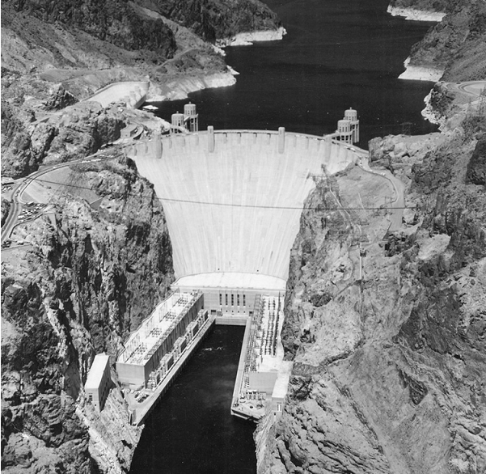
Fig 1: Hoover Dam, Colorado, completed in the 1930s but still one of the largest and most impressive arch dams in the world.
Arch dams are relatively thin walled and lighter in weight than gravity dams. They stand up to large deflections in the foundation rock, provided that the deflections are uniformly distributed. They transmit most of the horizontal thrust of the reservoir water to the abutments by arch action and this, together with their relative thinness, means that they impose high stresses on narrow zones at the base, as well as the abutments of the dam. Therefore, the strength of the rock mass at the abutments, and below and immediately down-valley of the dam must be unquestionable, and the modulus of elasticity must be high enough to ensure that its deformation under thrust from the arch is not so great as to induce excessive stresses in the arch. Ideal locations for arch dams are provided by narrow gorges where the walls are capable of withstanding the thrust produced by the arch action.
Buttress Dam
Buttress dams provide an alternative to other concrete dams in locations where the foundation rocks are competent. A buttress dam consists principally of a slab of reinforced concrete that slopes upstream and is supported by a number of buttresses whose axes are normal to the slab (Fig. 9.20). The buttresses support the slab and transmit the water load to the foundation. They are rather narrow and act as heavily loaded walls, thus exerting substantial unit pressures on the foundations.
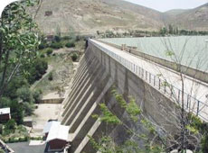
Fig 2: Ekbatan buttress dam (Iran)
Earth Dams
Earth dams are embankments of earth with an impermeable core to control seepage (Fig. 9.21). This usually consists of clayey material. If sufficient quantities are not available, then concrete or asphaltic concrete membranes are used. The core normally is extended as a cut-off or grout curtain below ground level when seepage beneath the dam has to be controlled. Drains of sand and/or gravel installed beneath or within the dam also afford seepage control.
Because of their broad base, earth dams impose much lower stresses on the foundation materials than concrete dams. Furthermore, they can accommodate deformation such as that due to settlement more readily. As a consequence, earth dams have been constructed on a great variety of foundations ranging from weak unconsolidated stream or glacial deposits to high-strength rocks.
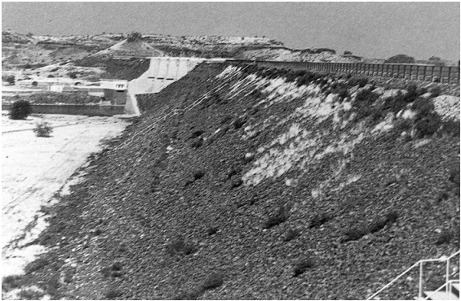
Fig 3: Harddap Dam, near Mariental, Namibia, and example of an embankment dam

Rockfill Dam
Rockfill dams usually consist of three basic elements - a loose rockfill dump, which forms the bulk of the dam and resists the thrust of the reservoir; an impermeable facing or membrane on the upstream side or an impermeable core; and rubble masonry in between to act as a cushion for the membrane and to resist destructive deflections. Consolidation of the main rock body may leave the face unsupported with the result that cracks form through which seepage can occur. Flexible asphalt membranes overcome this problem.
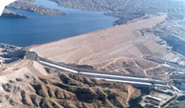
Fig 4: Karkeh Rockfill Dam (Iran)
Composite Dam
Some sites that are geologically unsuitable for a specific type of dam design may support one of composite design. For example, a broad valley that has strong rocks on one side and weaker ones on the other possibly can be spanned by a combined gravity and embankment dam, that is, a composite dam.
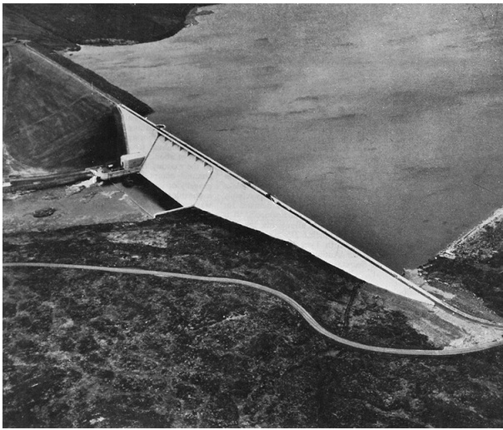
Fig 5: Cow Green Dam in Teesdale, northeast England, an example of a composite dam
Geology and Dam Sites
Of the various natural factors that directly influence the design of dams, none is more important than the geological, not only do they control the character of the foundation but they also govern the materials available for construction. The major questions that need answering include the depth at which adequate foundations exist, the strengths of the rock masses involved, the likelihood of water loss and any special features that have a bearing on excavation. The character of the foundations upon which dams are built and their reaction to the new conditions of stress and strain, of hydrostatic pressure and of exposure to weathering, must be ascertained so that the proper factors of safety may be adopted to ensure against subsequent failure. Excluding the weaker types of compaction shales, mudstones, marls, pyrolasts and certain very friable types of sandstone, there are few foundation materials deserving the name rock that are incapable of resisting the bearing loads even of high dams.
Suitability of Igneous Rocks for Dam Construction
In their unaltered state, plutonic igneous rocks essentially are sound and durable, with adequate strength for any engineering requirement. In some instances, however, intrusive may be highly altered by weathering or hydrothermal attack. Generally, the weathered product of plutonic rocks has a large clay content, although that of granitic rocks is sometimes porous with a permeability comparable to that of medium-grained sand, so that it requires some type of cut-off or special treatment of the upstream surface.
Thick massive basalts make satisfactory dam sites but many basalts of comparatively young geological age are highly permeable, transmitting water via their open joints, pipes, cavities, tunnels, and contact zones. Foundation problems in young volcanic sequences are twofold. Firstly, weak beds of ash and tuff may occur between the basalt flows that give rise to problems of differential settlement or sliding. Secondly, weathering during periods of volcanic inactivity may have produced fossil soils, these being of much lower strength.
Rhyolites, and frequently andesites, do not present the same severe leakage problems as young basalt sequences. They frequently offer good foundations for concrete dams, although at some sites chemical weathering may mean that embankment designs have to be adopted.
Suitability of Metamorphic Rocks for Dam Construction
Fresh metamorphosed rocks such as quartzite and hornfels are very strong and afford excellent dam sites. Marble has the same advantages and disadvantages as other carbonate rocks. Generally, gneiss has proved a good foundation rock for dams.
Cleavage, schistosity and, to a lesser extent, foliation in regional metamorphic rocks may adversely affect their strength and make them more susceptible to decay. Moreover areas of regional metamorphism usually have suffered extensive folding so that rocks may be fractured and deformed. Some schists, slates and phyllites are variable in quality, some being excellent for dam site purposes, others, regardless of the degree of their deformation or weathering, are so poor as to be wholly undesirable in foundations and abutments.

Effects of Joints
Joints and shear zones are responsible for the unsound rock encountered at dam sites on plutonic and metamorphic rocks. Unless they are sealed, they may permit leakage through foundations and abutments. Slight opening of joints on excavation leads to imperceptible rotations and sliding of rock blocks, large enough to appreciably reduce the strength and stiffness of the rock mass. Sheet or flat-lying joints tend to be approximately parallel to the topographic surface and introduce a dangerous element of weakness into valley slopes. Their width varies and, if they remain untreated, large quantities of water may escape through them from the reservoir.
Fault zones may be occupied by shattered or crushed material and so represent zones of weakness that may give rise to landslip upon excavation for a dam. The occurrence of faults in a river is not unusual, and this generally means that the material along the fault zone is highly altered. A deep cut-off is necessary in such a situation.
Suitability of Metamorphic Rocks for Dam Construction
Sandstones have a wide range of strength, depending largely on the amount and type of cement-matrix material occupying the voids. With the exception of shaley sandstone, sandstone is not subject to rapid surface deterioration on exposure. As a foundation rock, even poorly cemented sandstone is not susceptible to plastic deformation. However, friable sandstones introduce problems of scour at the foundation. Moreover, sandstones are highly vulnerable to the scouring and plucking action of the overflow from dams and have to be adequately protected by suitable hydraulic structures. A major problem of dam sites located in sandstones results from the fact that they normally are transected by joints, which reduce resistance to sliding. Generally, however, sandstones have high coefficients of internal friction that give them high shearing strengths, when restrained under load.
Sandstones frequently are interbedded with shale. These layers of shale may constitute potential sliding surfaces. Sometimes, such interbedding accentuates the undesirable properties of the shale by permitting access of water to the shale–sandstone contacts. Contact seepage may weaken shale surfaces and cause sliding in formations that dip away from abutments and spillway cuts. Severe uplift pressures also may develop beneath beds of shale in a dam foundation and appreciably reduce its resistance to sliding.
Limestone dam sites vary widely in their suitability. Thick-bedded, horizontally lying limestones, relatively free from solution cavities, afford excellent dam sites. Also, limestone requires no special treatment to ensure a good bond with concrete. On the other hand, thin-bedded, highly folded or cavernous limestones are likely to present serious foundation or abutment problems involving bearing capacity or watertightness or both (Soderburg, 1979). Resistance to sliding involves the shearing strength of limestone. If the rock mass is thin bedded, a possibility of sliding may exist. This should be guarded against by suitably keying the dam structure into the foundation rock. Beds separated by layers of clay or shale, especially those inclined downstream, may serve as sliding planes under certain conditions.
Well cemented shales, under structurally sound conditions, present few problems at dam sites, though their strength limitations and elastic properties may be factors of importance in the design of concrete dams of appreciable height. They, however, have lower moduli of elasticity and lower shear strength values than concrete and, therefore, is unsatisfactory foundation materials for arch dams. Moreover, if the lamination is horizontal and well developed, then the foundations may offer little shear resistance to the horizontal forces exerted by a dam.
Ground Improvement
Grouting has proved effective in reducing percolation of water through dam foundations, and its introduction into dam construction has allowed considerable cost saving by avoiding the use of deep cut-off and wing trenches. Consequently, many sites that previously were considered unsuitable because of adverse geological conditions can now be used.
Initial estimates of the groutability of ground frequently have been based on the results of pumping-in tests, in which water is pumped into the ground via a drillhole. Lugeon (1933) suggested that grouting beneath concrete gravity dams was necessary when the permeability exceeded 1 lugeon unit (i.e. a flow of 1 l m-1 min-1 at a pressure of 1 MPa). However, this standard has been relaxed in modern practice, particularly for earth dams and for foundations in which seepage is acceptable in terms of lost storage and non-erodibility of foundation or core materials (Houlsby, 1990).
The effect of a grout curtain is to form a wall of low permeability within the ground below a dam. Holes are drilled and grouted, from the base of the cut-off or heel trench downwards. Where joints are vertical, it is advisable to drill groutholes at a rake of 10–15∞, since these cut across the joints at different levels, whereas vertical holes may miss them. The rate at which grout can be injected into the ground generally increases with an increase in the grouting pressure, but this is limited since excessive pressures cause the ground to fracture and lift (Kennedy, 2001). The safe maximum pressure depends on the weight of overburden, the strength of the ground, the in situ stresses and the pore water pressures.

